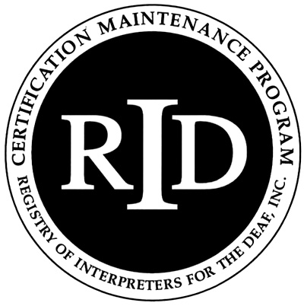 **Academic Coursework Activity Report**

Note to participant:

This activity form must be submitted to the RID Approved Sponsor upon completion of the academic course.

A copy of the description of the course and the Institution’s transcript or grade report should be attached. The Sponsor will enter the activity information and CEUs online at myaccount.rid.org.

Participant Name (print): Click here to enter text. RID Member #: Click here to enter text.

Participant Address: Click here to enter text.

Participant Email: Click here to enter text. Phone #: Click here to enter text.

Participant Cycle End Date (if applicable): Click here to enter a date.

Course Title: Click here to enter text.

Name of College or University: Click here to enter text.

What is the number of credit hours assigned to the course? Click here to enter text./semester or Click here to enter text./quarter

Name of Approved Sponsor: Click here to enter text.

RID Activity Number for this Academic Coursework:

Click here to enter text. Click here to enter text.

Sponsor Code . Month .Year . Ascending within month; Internal Code (optional)

To which *Content Area* does this course apply?  Professional Studies  General Studies

Course Start Date: Click here to enter a date. Course Completion Date: Click here to enter a date.

Number of Continuing Education Credits* (CEUs) awarded to CMP participant:Click here to enter text.

(*1.5 CEU/credit based on a *Semester* session or 1.0 CEU/credit based on a *Quarter* session.

As an RID member, I certify that this academic coursework represents a valid and verifiable Continuing Education experience which exceeds routine employment responsibilities.

Signature of Participant Click here to enter text. Date Click here to enter a date.

As the RID Approved Sponsor for this Academic Course activity, I have verified successful completion of the course and a grade of “C” (2.0 GPA) or better and the course was taken at an accredited institution recognized by the Council for Higher Education Accreditation (CHEA) or U.S. or the European Quality Assurance Register for Higher Education .

Signature of RID Approved Sponsor Administrator Click here to enter text. Date Click here to enter a date.

Updated March 2016