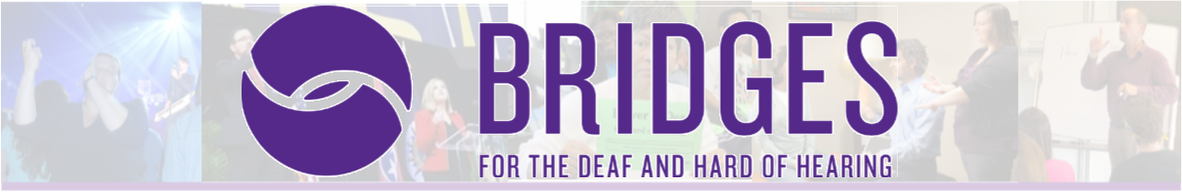
Interpreter Workshop Series 2020
Presenter: William F. Ross, III

Defy the Status Quo | August 28, 2020 | 6:00pm-9:00pm for 0.3 PS CEUs
Each sign language interpreter has a role and accompanying responsibilities that are all encompassing; linguistic, logistic, behavioral and relational (to name a few). Every decision we make is loaded with ethical implications that can impact the life and liberty of members of the Deaf community. But, have you ever stopped to consider WHY you make the decisions you do? We are clearly influenced by multiple factors, some of which are, the laws of the legal system, the Code of Professional Conduct, and individual workplace policies and procedures. However, this workshop proposes, the historic values of our profession hold sway over our belief system and subsequently our behavior. The antiquated values of neutrality, invisibility, secrecy and the overemphasis on role continue to influence practitioners, both new and old alike. It is vital that we understand the depth of these rooted values and our profession’s drive to maintain the status quo. Together, we will examine and discuss why we lean in one “ethical direction” instead of another and its impact on community trust. Consideration will be given to relational autonomy and the conditions that foster transparent decision-making by interpreters and the other individuals involved in the interpreting process.

Being Comfortable in the Uncomfortable| August 29, 2020 | 9:00am-4:30pm for 0.6 PS CEUs (1.5 hour lunch)
Sign Language interpreting is not a profession for those who are uncomfortable with change. Interpreting is an ever developing field that requires its practitioners to change, adapt, and grow. Often, the issue is not the lack of desire to change, but rather the ability to create lasting change. How do we, as interpreters, know what we should be changing; what should we keep, tweak or trash? How can we improve our work in ways that are identifiable and visible? In this training we will examine some of the features of change and how to recognize the evidence of genuine change. In addition, we will practice transforming our current work. Specific tools will be utilized to create a path and plan to guide long term and lasting changes to our work – both linguistic and interpreting.

Cost: $30 for Defy the Status Quo and $60 for Bring Comfortable in the Uncomfortable OR $80 for both
Cancellation Prior to July 20 = Full Refund, Cancellation July 20-August 21 = 50% refund
Cancellation after August 21 = No Refund CLICK HERE to Register.

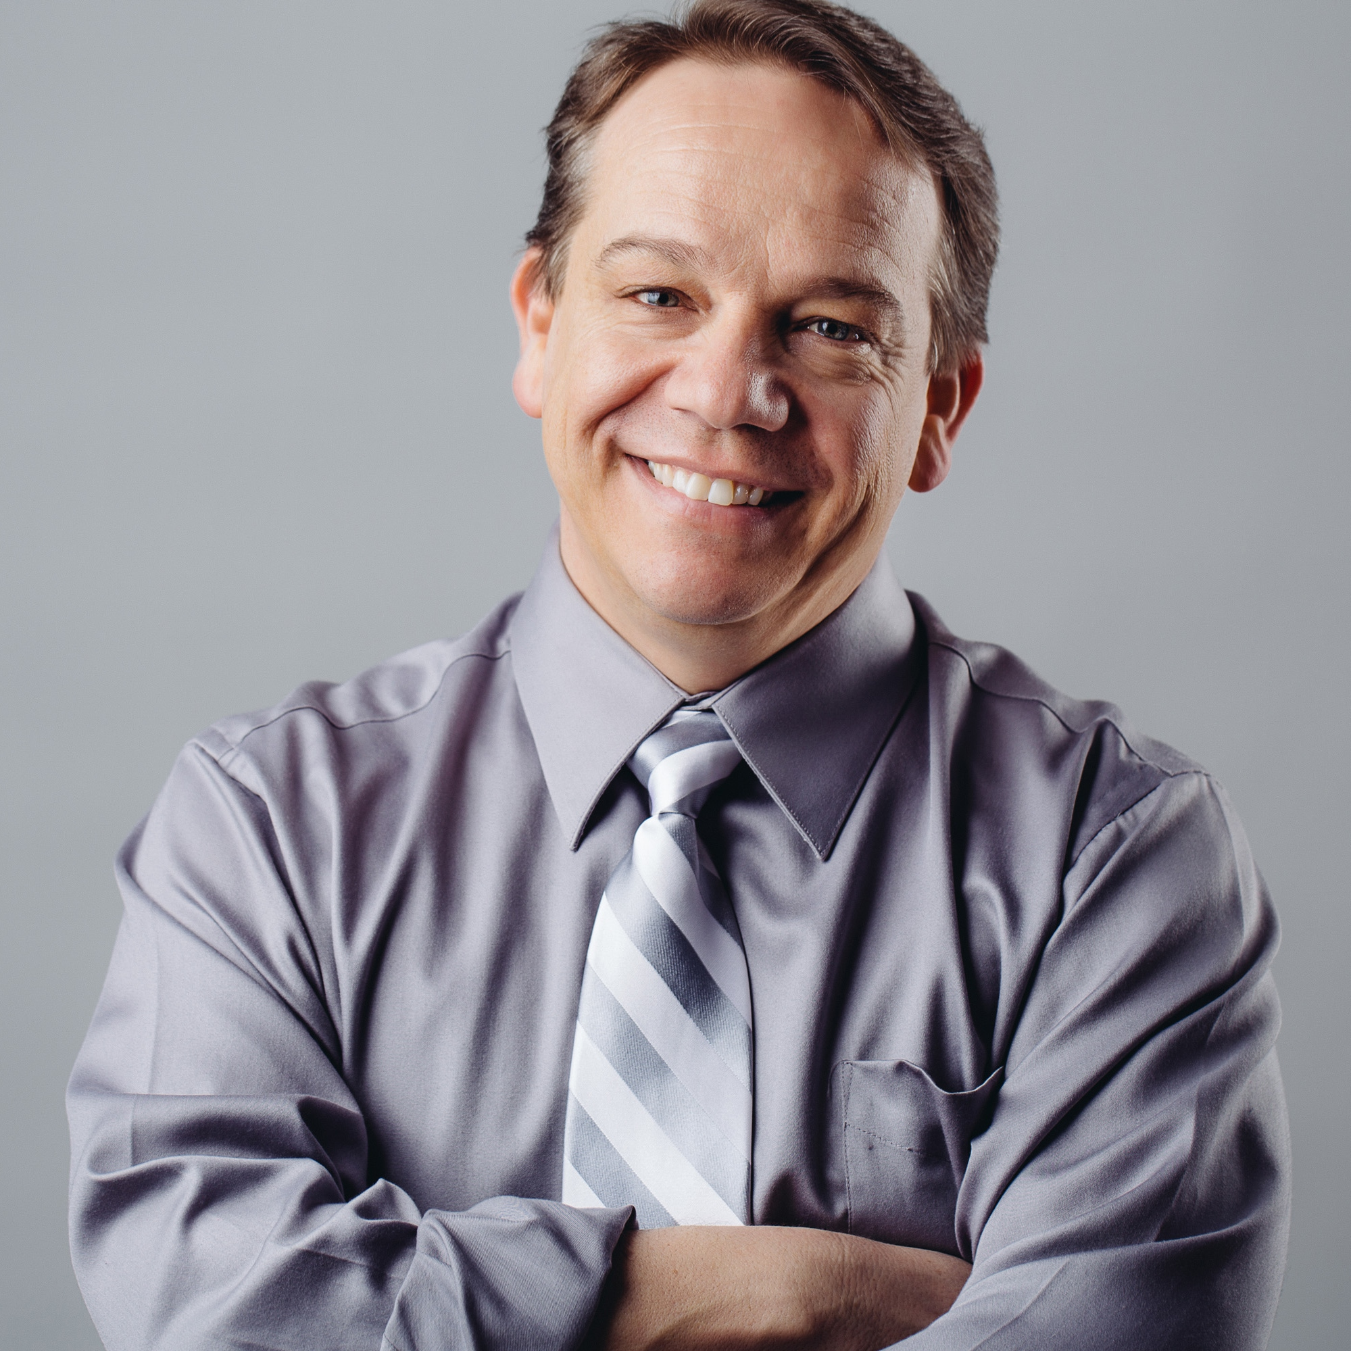
About the Presenter
William F. Ross III, a child of Deaf parents, has been interpreting for more than 36 years and holds dual certification (CI/CT) from the Registry of Interpreters of the Deaf. He has a Master of Science Degree in Special Education from Missouri State University. Currently, Bill is the Curriculum Development Specialist at Deaf Bible Society (DBS); developing trainings and resources for individuals who work on Bible translation into Sign Language. Prior to coming to DBS, he was the Program Director of the Carlstrom Interpreter Training Program at North Central University in Minneapolis, Minnesota. Mr. Ross was previously the Director of the Communication Access Support Services Department at North Carolina School for the Deaf (NCSD); where he established the NCSD Mentorship Project and Distance Learning Mentoring Program to provide ongoing support to educational and freelance interpreters. He is passionate about building mentoring relationships, studying ASL and accompanying interpreters on the journey of perfecting their craft.
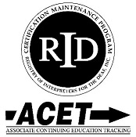
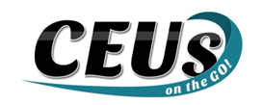

Should you require any accommodations, please contact Amy Lankheit at amy@bridgesfordeafandhh.org prior to August 21. 2020. This event upholds nondiscriminatory practices and encourages a learning environment of mutual respect and free from bias. CEUs on the Go! is an Approved RID CMP Sponsor for Continuing Education Activities. These PS programs are offered for 0.3 CEUs at the Some Content Knowledge Level for Defy the Status Quo and 0.6 CEUs at the Some Content Knowledge Level for Being Comfortable in the Uncomfortable.

