Avoiding the Landmines in Mental Health Interpreting

J. Eric Workman
February 28, 2020
5:00-8:00pm
Bridges for the Deaf and Hard of Hearing
935 Edgehill Ave, Nashville, TN 37203

Cost: Free | Refreshments provided

Register: Contact Amy Lankheit at amy@bridgesfordeafandhh.org by Feb 21, 2020 to register and/or accommodations.

Mental health interpreting while on the surface seems straight forward, is full of pitfalls that have long-lasting and life-changing results for those we serve. This workshop will discuss those landmines that interpreters often fall into due to being unprepared or unaware of how their work and actions impact one’s treatment.
About the Presenter
J. Eric Workman is currently the Vice President of Interpreting Services at Bridges for the Deaf and Hard of Hearing. He is a 2002 graduate of Eastern Kentucky University’s Interpreter Training Program. Eric has been interpreting in the legal arena for twelve years. His experience ranges from law enforcement interrogations to jury trials. His passion for legal interpreting continues to grow and he is able to spread the word about best practices for American Sign Language interpreters working in the judiciary.
He currently resides in Franklin, Tennessee with his wife and two sons.

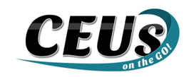
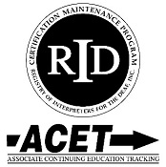

Should you require any accommodations, please contact Amy Lankheit at amy@bridgesfordeafandhh.org prior to Feb 21. 2020. This event upholds nondiscriminatory practices and encourages a learning environment of mutual respect and free from bias.

CEUs on the Go! is an Approved RID CMP Sponsor for Continuing Education Activities. This PS program is offered for 0.3 CEUs at the Some Content Knowledge Level.

