**Participant Initiated Non-RID Activities** 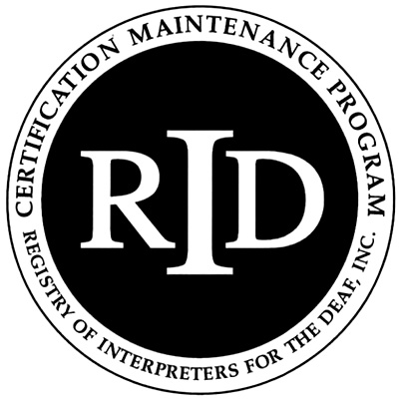

**(PINRA)**

This form will be used if an RID member plans to attend another organization’s workshop, conference, formal in-service training or activity. The RID Approved Sponsor will determine if the activity is appropriate for CEUs.

**Before the start of the activity/conference, this section must be filled out**

**and signed by both the participant and RID Approved Sponsor:**

Participant Name: Click here to enter text. RID Member #: Click here to enter text.

Participant Address: Click here to enter text.

Email: Click here to enter text. Phone #: Click here to enter text.

Activity/Conference Name: Click here to enter text.

Activity/Conference Theme or Focus (attach brochure/flyer) Click here to enter text.

Date and Times of activities you will attend: Click here to enter text.

Total number of CEUs to be awarded: Click here to enter text.

Circle content area: Professional Studies  General Studies

I certify that this activity/conference represents a valid and verifiable Continuing Education Experience that exceeds

routine employment responsibilities.

Participant Signature: Click here to enter text. Date: Click here to enter a date.

===========================================================================

Name and Code of RID Approved Sponsor: Click here to enter text. Click here to enter text.

I certify that I received this activity plan prior to the start of the activity/conference and I agree to sponsor this Continuing Education Experience. I will verify successful completion prior to awarding CEUs.

RID Sponsor Administrator Name: Click here to enter text. Signature: Click here to enter text.

RID Sponsor Code: Click here to enter text. Date: Click here to enter a date.

**This section must be filled out and signed upon *completion* of the activity/conference:**

Activity Code Number Click here to enter text. CEUs Awarded: Click here to enter text.

I have verified that the participant attended this activity/conference and that the activities listed are appropriate educational experiences which should be awarded the number of CEUs denoted above.

RID Approved Sponsor Signature Administrator: Click here to enter text.Date: Click here to enter a date.

**The Participant must send documentation of attendance to the Sponsor upon completion of the activity. The Sponsor must file this form with RID online at** **myaccount.rid.org** **within 45 days of the completion of the activity/conference.**