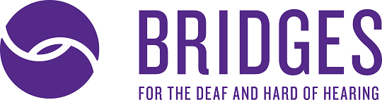

Legal Interpreting: Procedures, Part 2
Presenter: J. Eric Workman
July 30, 2019 | 5:30pm-7:30pm
Bridges for the Deaf and Hard of Hearing
935 Edgehill Ave | Nashville, TN 37203

Cost: Free | Pizza and drinks will be provided

Register: Contact Amy Lankheit at amy@bridgesfordeafandhh.org by July 23, 2019 to register.

This workshop will focus on lesser-known aspects of legal interpreting and settings. Settings that will be discussed include depositions, law enforcement, and working with Deaf Interpreters in court. Legal terminology and procedures will also be discussed.
About the Presenter
J. Eric Workman is currently the Vice President of Interpreting Services at Bridges for the Deaf and Hard of Hearing. He is a 2002 graduate of Eastern Kentucky University’s Interpreter Training Program. Eric has been interpreting in the legal arena for twelve years. His experience ranges from law enforcement interrogations to jury trials. His passion for legal interpreting continues to grow and he is able to spread the word about best practices for American Sign Language interpreters working in the judiciary.
He currently resides in Franklin, Tennessee with his wife and two sons.
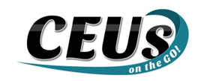
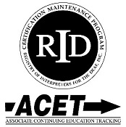

Should you require any accommodations, please contact Amy Lankheit at amy@bridgesfordeafandhh.org prior to July 23, 2019. This event upholds nondiscriminatory practices and encourages a learning environment of mutual respect and free from bias.

CEUs on the Go! is an Approved RID CMP Sponsor for Continuing Education Activities. This PS program is offered for 0.2 Legal CEUs at the Some Content Knowledge Level.

